Invertebrate Handout
USE YOUR LAB MANUAL TO FILL OUT THE BOXES:
Members of the Domain Eukarya can be multicellular, have a nucleus and have organelles
Members of the Kingdom Animalia are ingestive-feeding heterotrophs (meaning they eat others by ingesting them).
Phylum: Members of the Kingdom Animalia belong to the following Phyla; Porifera, Cnidaria, Platyhelminthes, Nematoda, Mollusca, Annelida and Arthropoda, are considered Invertebrates (no spine). Members of each Phyla share certain characteristics. Use your lab manual to fill out what they have in common.
Body Plan: Asymmetrical (No way to cut into two equal halves)
Radial (Many different ways of cutting into two equal halves ex: Pizza)
Bilateral (Only one way to cut in two equal halves ex: Fork)

Tissue (germ) layers: No tissues
2 Tissues (Endoderm and Ectoderm)
3 Tissues (Endoderm, Mesoderm, Ectoderm)

Body Cavities: 2 Tissue Organism Gastrovascular cavity
3 Tissue Organism Acoelomate (No space between the tissues)
Pseudocoelomate (A small space between the tissues)
Coelomate (A large space between the tissues)

Development of Body Openings: Protostome: Mouth developed before anus
(COELOMATES ONLY) Deuterostome: Anus Developed before mouth

Phylum Porifera:
All members of this phylum:
Organism: _SPONGE___
Domain: Eukarya
Kingdom: Animalia
Phylum: Porifera
Species: Verongia
Body Plan: Asymmetrical
Germ Layers: No Tissues
Body Cavity: No True Body Cavity but does have an Osculum

Insert picture of Verongia Sponge

Phylum Cnidaria:
All members of this phylum:

Organism: _ Jellyfish_
Domain:
Kingdom:
Phylum:

Species:
Body Plan:
Germ Layers:
Body Cavity:
Orientation: Medusa or Polyp
Insert picture of Portuguese Man of War

Organism: _ Hydra_
Domain:
Kingdom:
Phylum:

Species:
Body Plan:
Germ Layers:
Body Cavity:
Orientation: Medusa or Polyp

Insert picture of Hydra

Organism: _ Coral_
Domain:
Kingdom:
Phylum:

Species:
Body Plan:
Germ Layers:
Body Cavity:
Orientation: Medusa or Polyp

Insert picture of Tubipora Coral

Phyla Platyhelminthes
All members of this phylum:
Organism: _ Taenia solium (tapeworm)_
Domain:
Kingdom:
Phylum:
All members of this Phylum are:
Species:

Species:
Body Plan:
Germ Layers:
Body Cavity:

Insert picture of Taenia solium

Phylum Nematoda
All members of this phylum:
Organism: _ Ascaris
Domain:
Kingdom:
Phylum:
All members of this Phylum are:
Species:

Species:
Body Plan:
Germ Layers:
Body Cavity:

Insert picture of Ascaris

Phyla Mollusca
All members of this phylum:
Organism: _ Land Snail_
Domain:
Kingdom:
Phylum:
Class:
All members of this class move using:

Species:
Body Plan:
Germ Layers:
Body Cavity:
Development of body opening:
Insert picture of Land Snail

Organism: _ Anadonta Clam_
Domain:
Kingdom:
Phylum:
Class:
All members of this class move using:

Body Plan:
Germ Layers:
Body Cavity:
Development of body opening:

Insert picture of Anadonta Clam

Organism: _ Octopus_
Domain:
Kingdom:
Phylum:
Class:
All members of this class move using:

Species:
Body Plan:
Germ Layers:
Body Cavity:
Development of body opening:

Insert picture of Octopus

Phylum Annelida
All members of this phylum:
Organism: _ Nereis worm_
Domain:
Kingdom:
Phylum:
Class:
All members of this class are:

Species:
Body Plan:
Germ Layers:
Body Cavity:
Development of body opening:
Insert picture of Nereis worm

Organism: _ Earthworm_
Domain:
Kingdom:
Phylum:
Class:
All members of this class have:

Species:
Body Plan:
Germ Layers:
Body Cavity:
Development of body opening:

Insert picture of Earthworm

Organism: _ Leech_
Domain:
Kingdom:
Phylum:
Class:
All members of this class are:

Species:
Body Plan:
Germ Layers:
Body Cavity:
Development of body opening:

Insert picture of Leech

Phyla Arthropoda
All members of this phylum:
Subphylum Chelicerata
All members of this subphylum have:
Organism: _ Horseshoe Crab
Domain:
Kingdom:
Phylum:
Subphylum (group):
All members of this subphylum have ____ body regions
_______________ & ____________________

Body Plan:
Germ Layers:
Body Cavity:
Development of body opening:
Insert picture of Horsehoe crab

Organism: _Black Widow Spider _
Domain:
Kingdom:
Phylum:
Subphylum (group):
Class:
All members of this class are:

Species:
Body Plan:
Germ Layers:
Body Cavity:
Development of body opening:

Insert picture of Black widow Spider

Subphylum Crustacea
Organism: _ Crayfish
Domain:
Kingdom:
Phylum:
All members of this Phylum have :
Subphylum (group):
All members of this subphylum have ____ body regions
____________________ & ____________________

Species:
Body Plan:
Germ Layers:
Body Cavity:
Development of body opening:
Insert picture of Crayfish

Organism: _ Centipede_
Domain:
Kingdom:
Phylum:
Subphylum (group):
All members of this subphylum have:

Species:
Body Plan:
Germ Layers:
Body Cavity:
Development of body opening:

Insert picture of Centipede

Organism: _millipede
Domain:
Kingdom:
Phylum:
Subphylum (group):

Species:
Body Plan:
Germ Layers:
Body Cavity:
Development of body opening:

Insert picture of millipede

Subphylum Myriapoda

Class Insecta:

Organism: _ Grasshopper
Domain:
Kingdom:
Phylum:
Class:
All members of this class:
Species:

Body Plan:
Germ Layers:
Body Cavity:
Development of body opening:
Insert picture of Grasshopper

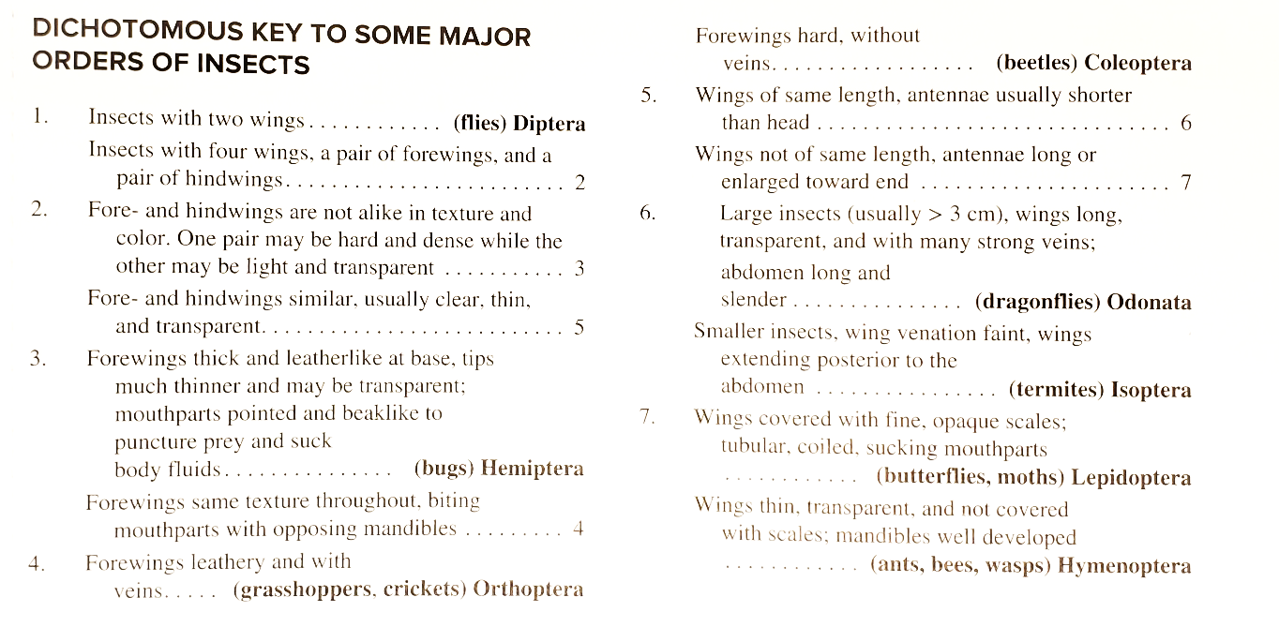
Dichotomous Key: Use the following Dichotomous Key to identify the order of the insects listed below:

House Fly: ORDER __________
Ant: ORDER __________
Cockroach: ORDER __________
Grasshopper: ORDER __________
Butterfly: ORDER _________

